Ethan Herndon  
CST 311

Lab 4

Screenshot 1 for question 1:

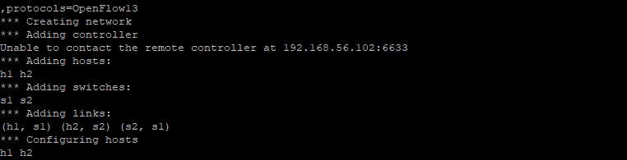

Screenshot 2 for question 2,3,4:

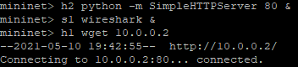

2A: **In Part A step 6 what system (i.e. at what prompt did you start wireshark) and interface did you use to see the OpenFlow traffic?**

I saw eth0.

**What version of openflow did you need to select in Wireshark to filter the traffic to see just OpenFlow packets?**

openflow_v4